GitHub Capstone Project

Project – 1 :

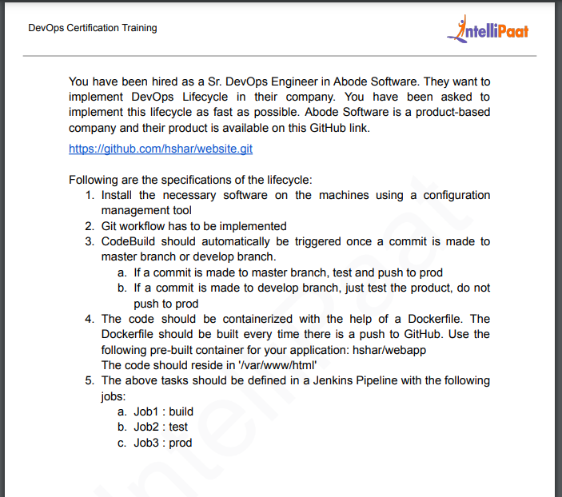

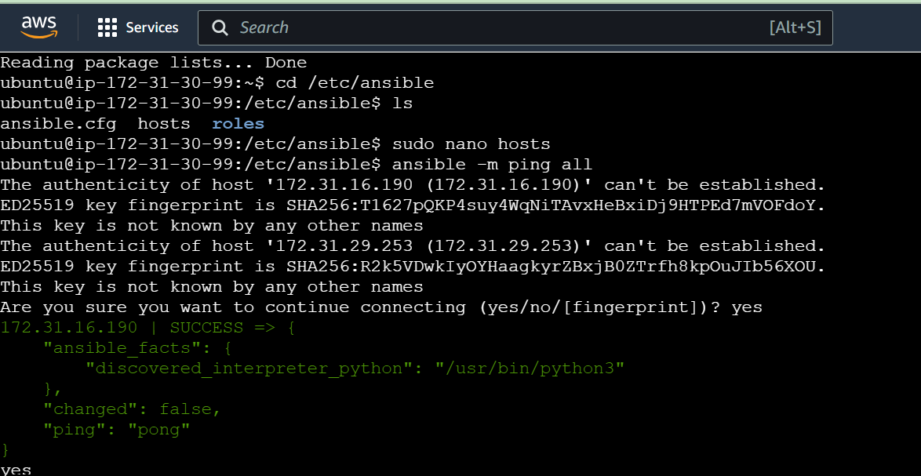

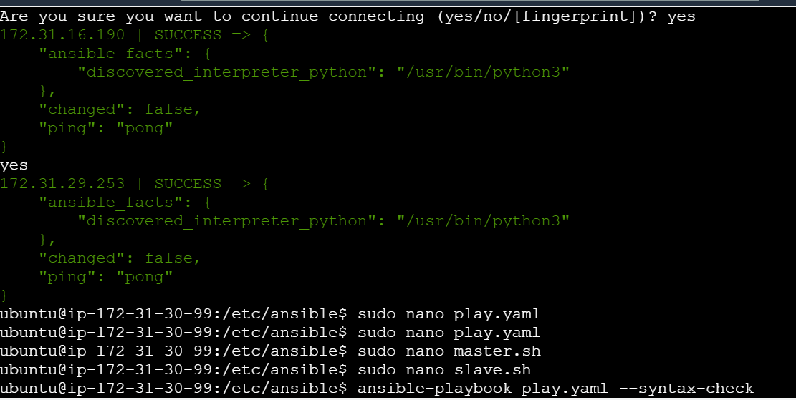

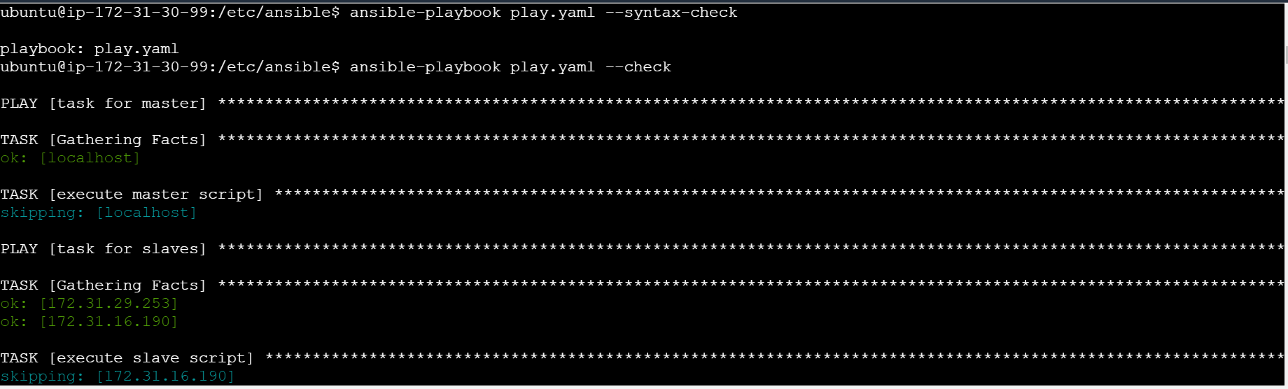

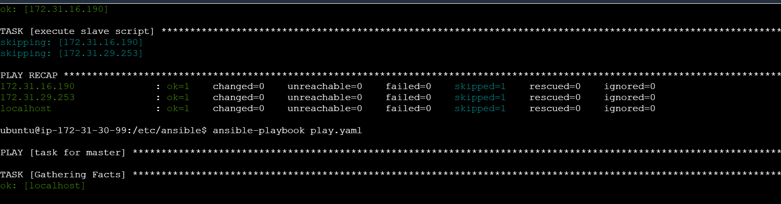

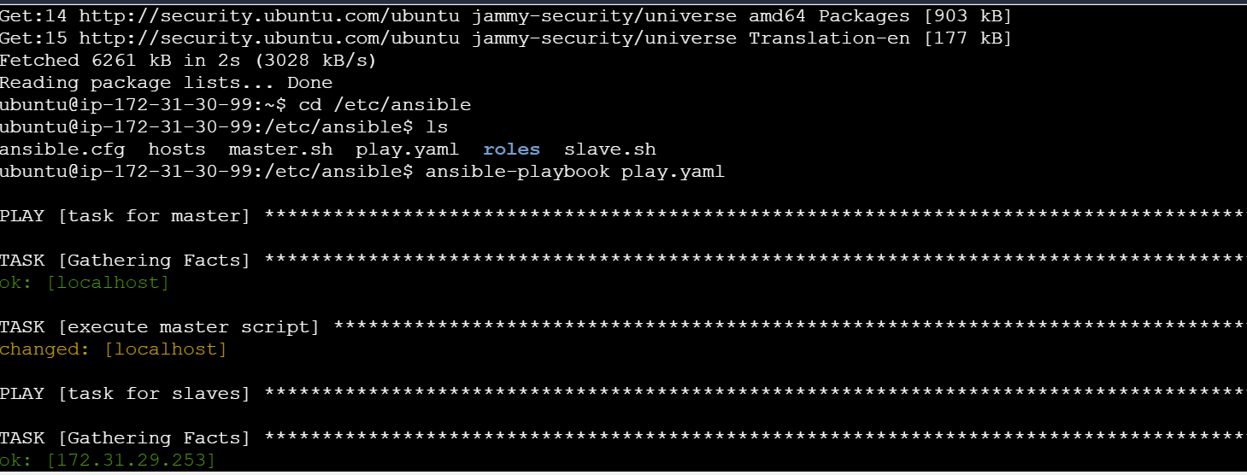

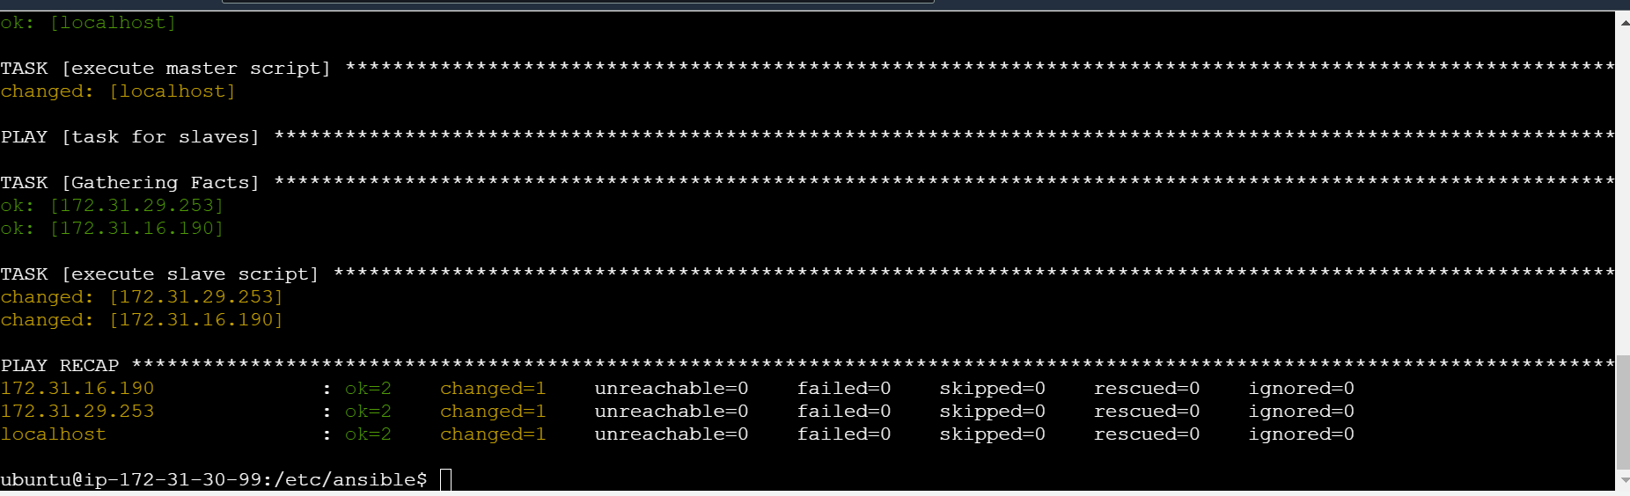

Java is installed in Test and Prod slaves:

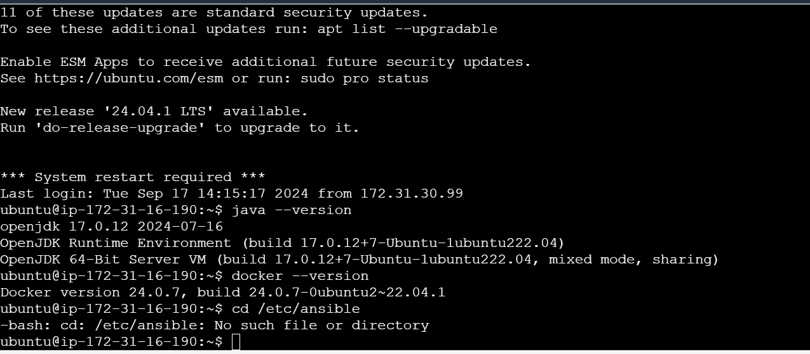

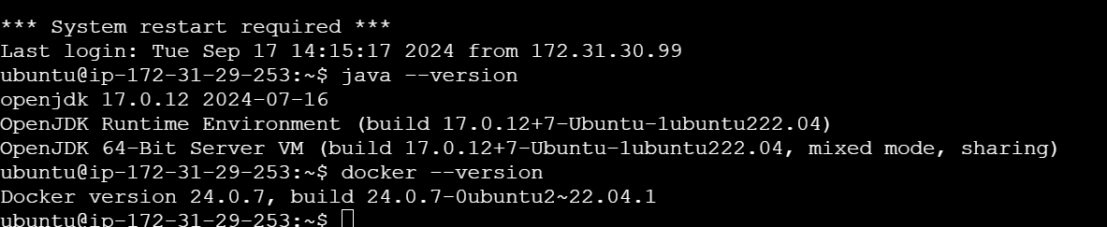

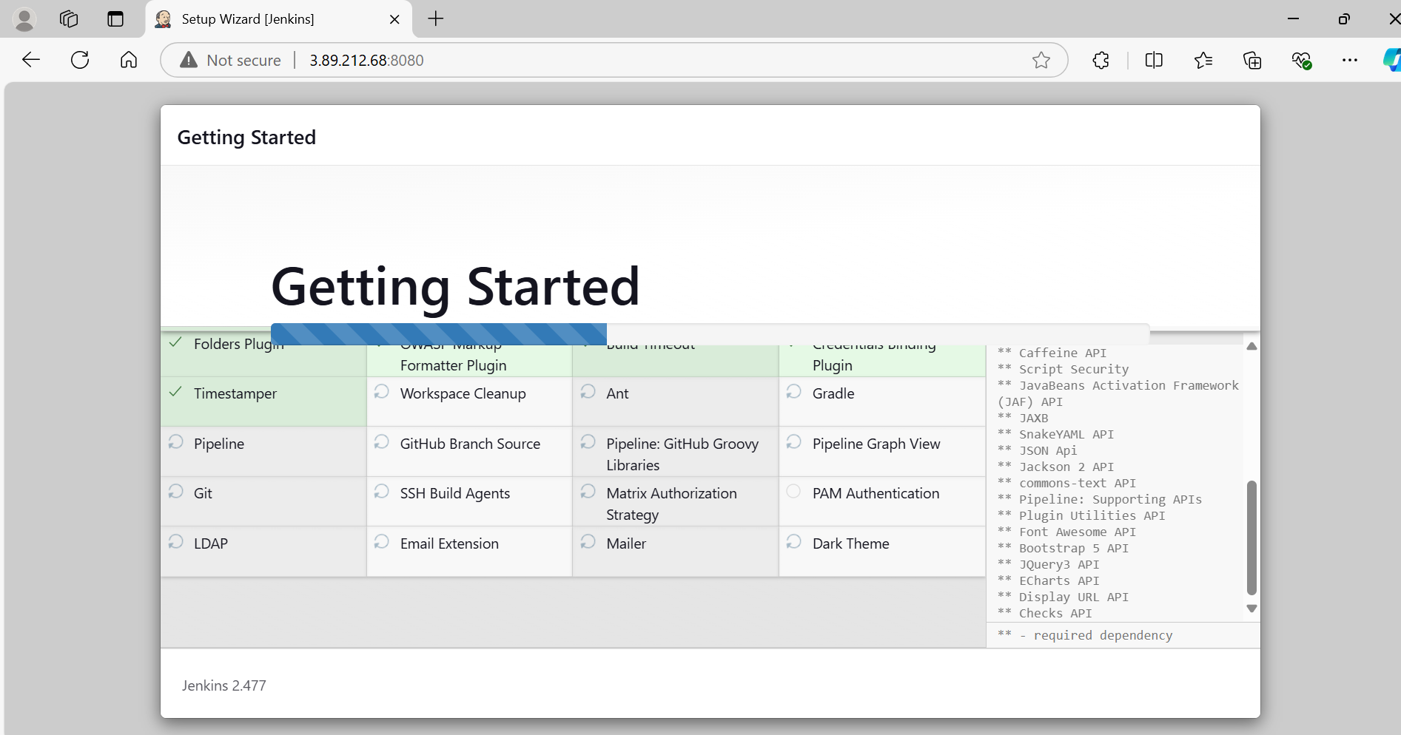

Create plugins :

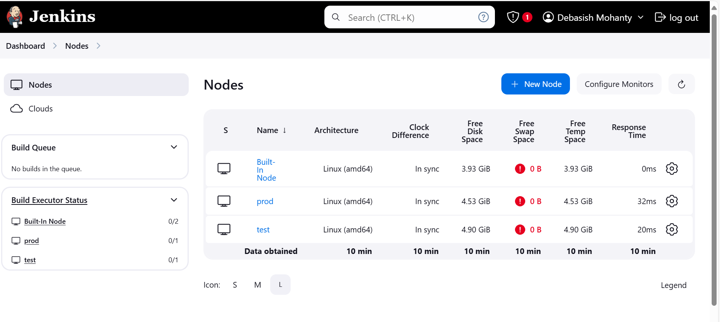

Creating a dockerfile in both master and develop branch.

FROM ubuntu

RUN apt-update

RUN apt install apache2 -y

ADD . /var/www/html/

ENTRYPOINT apachectl -D FOREGROUND

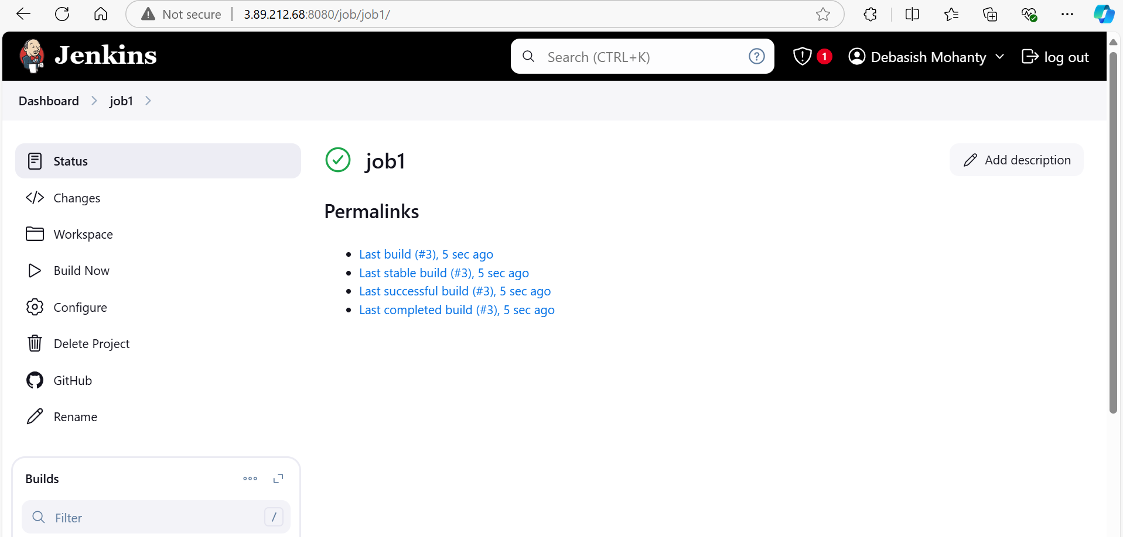

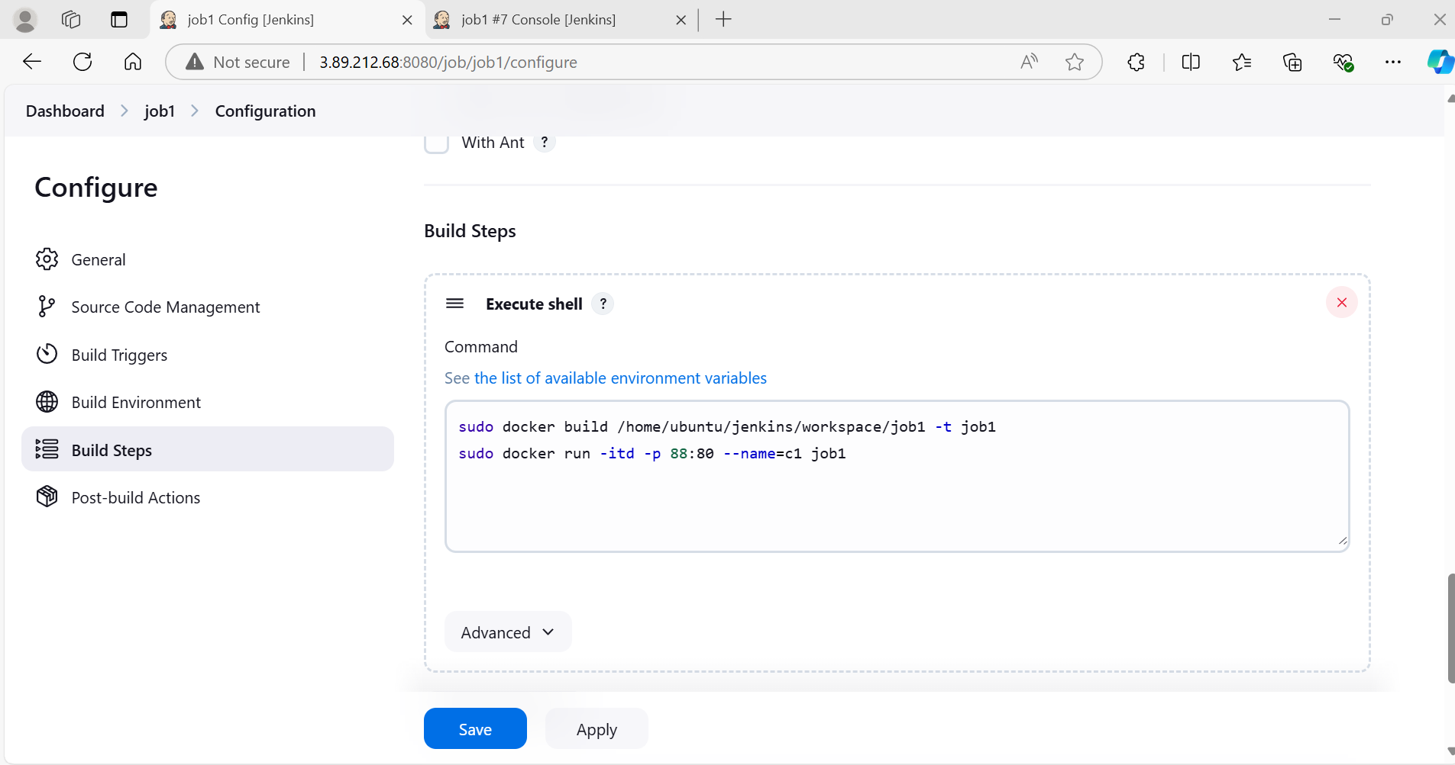

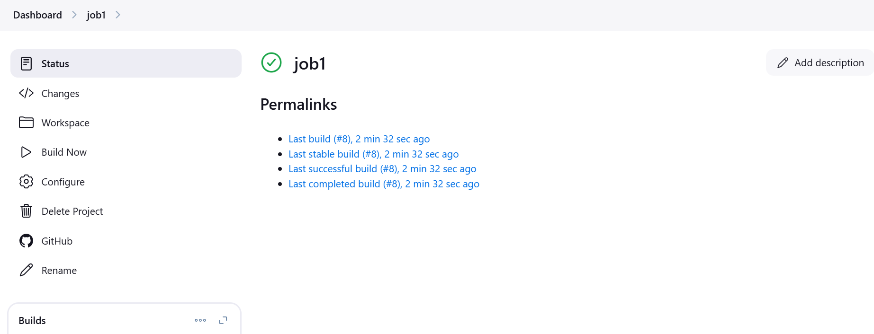

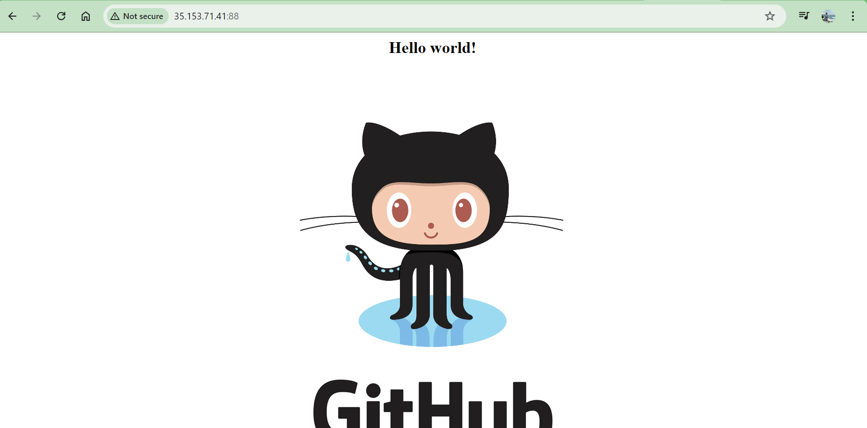

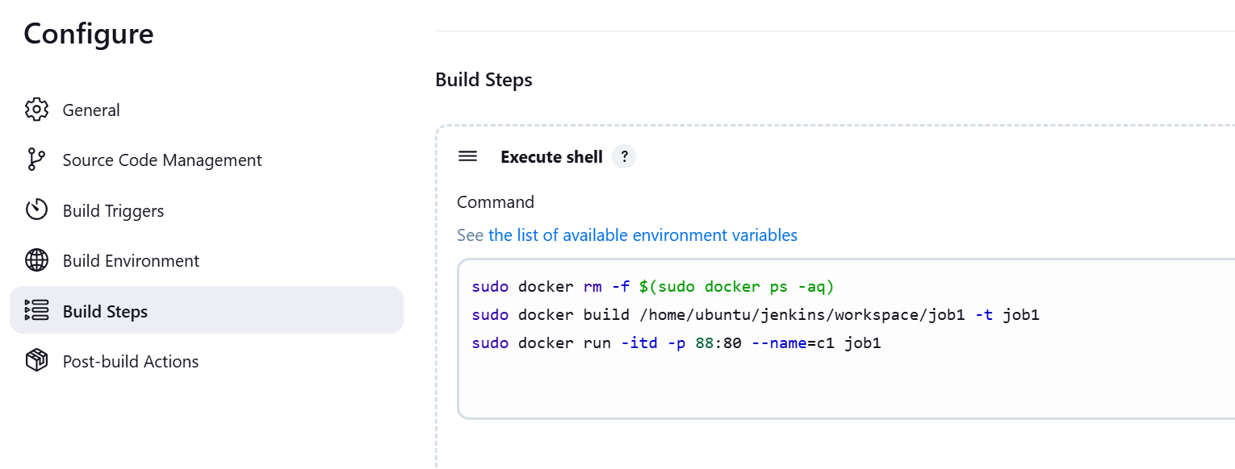

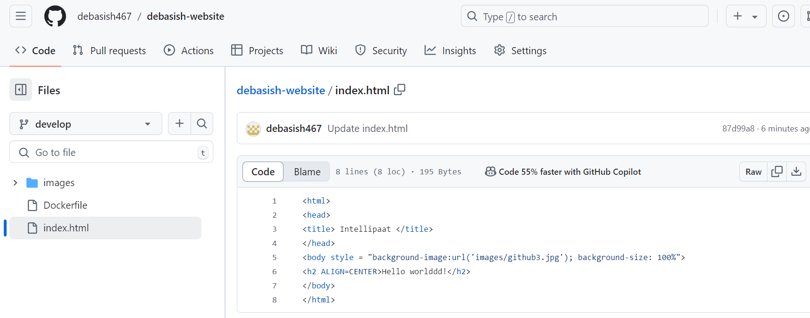

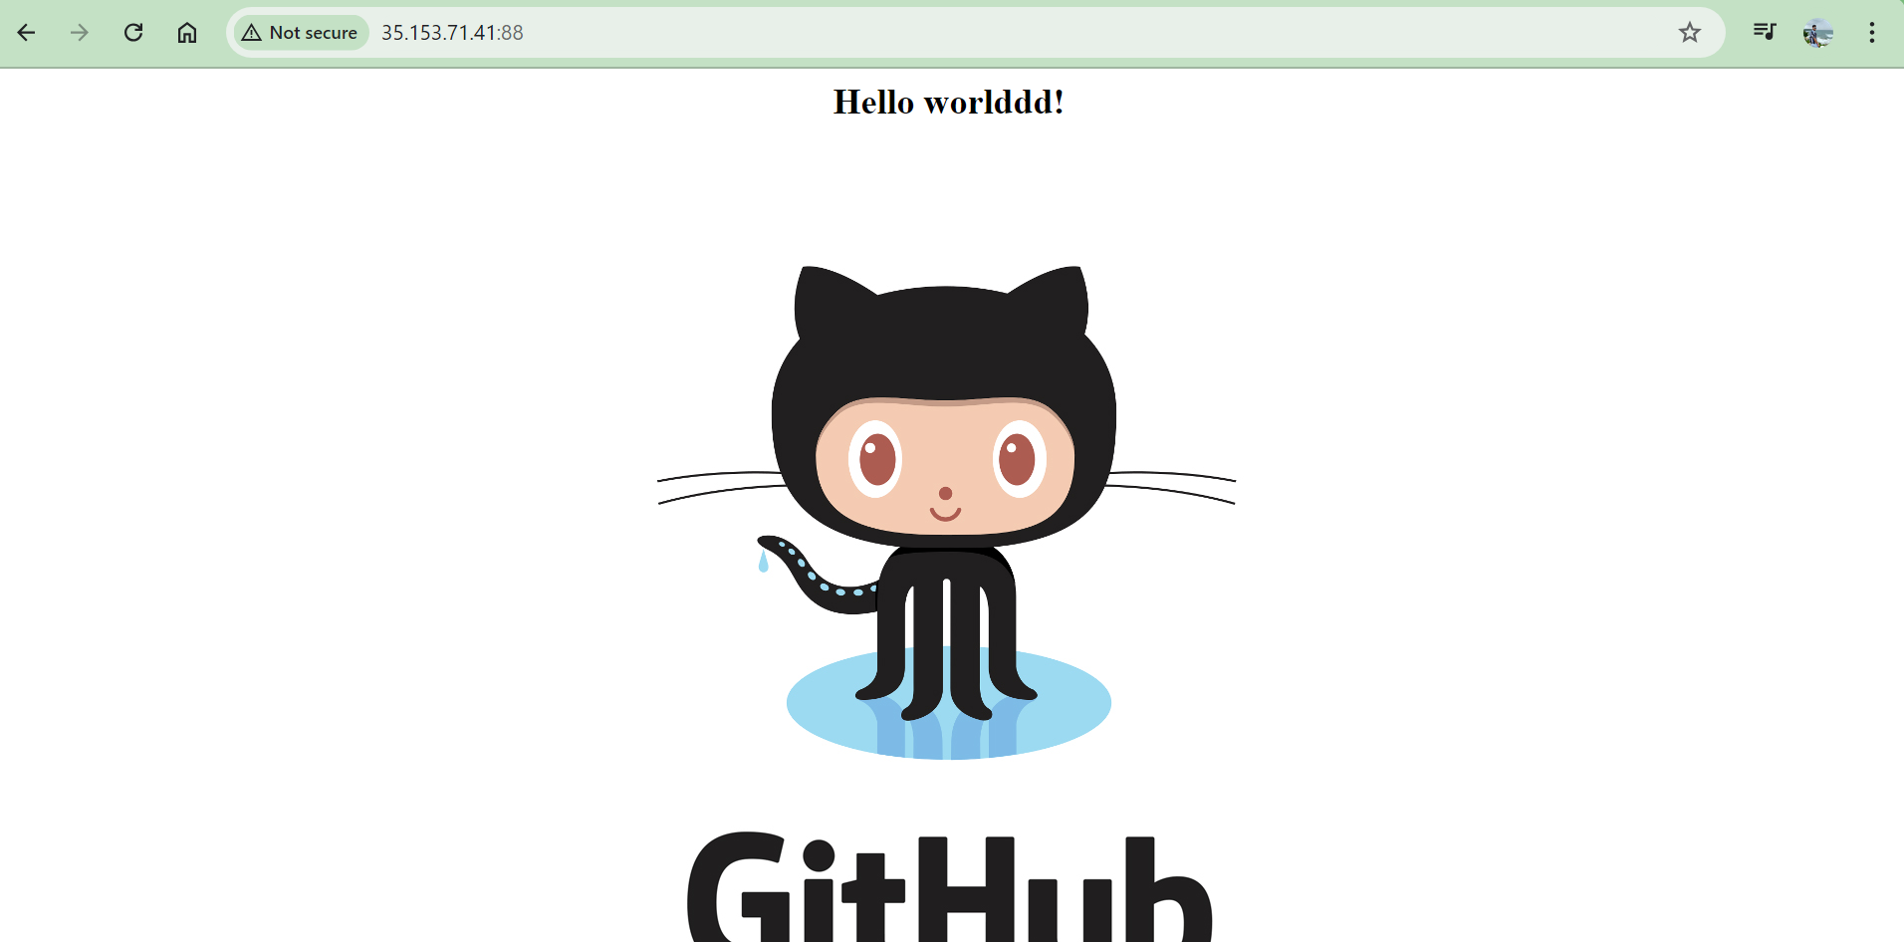

Now for Job2 we must repeat the steps:

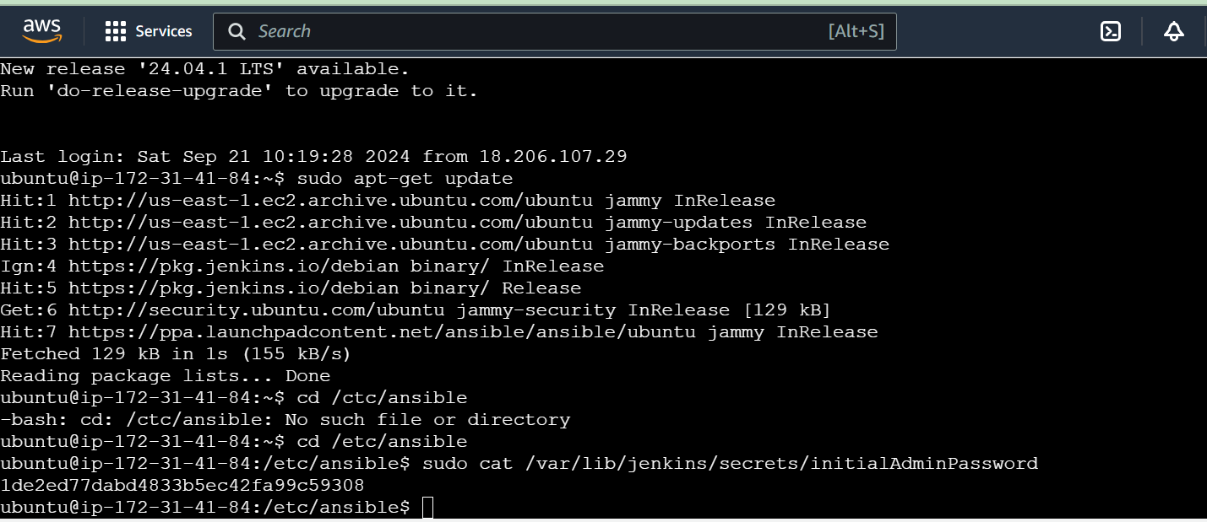

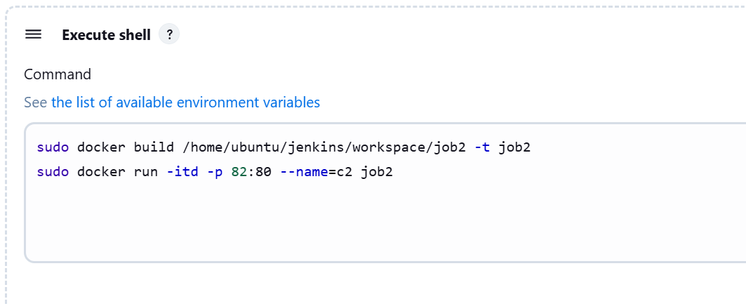

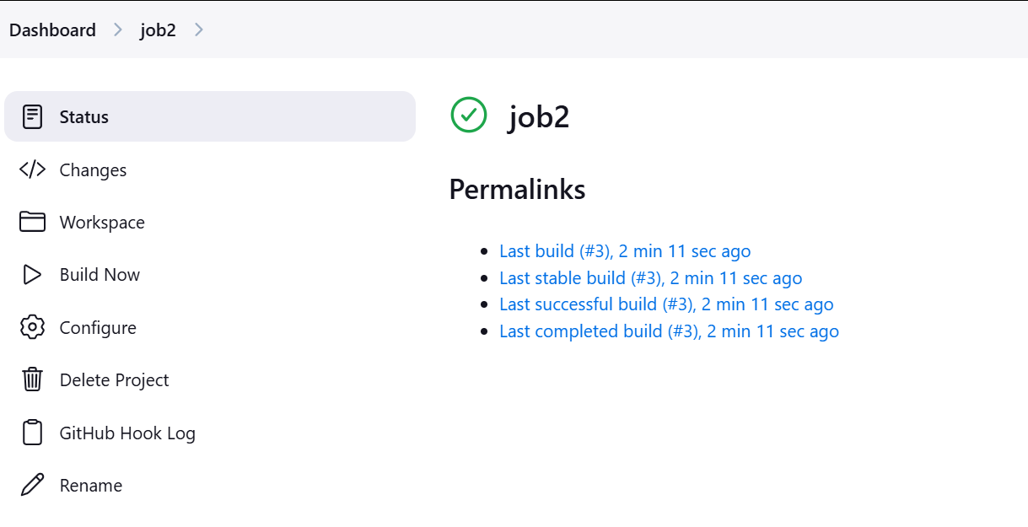

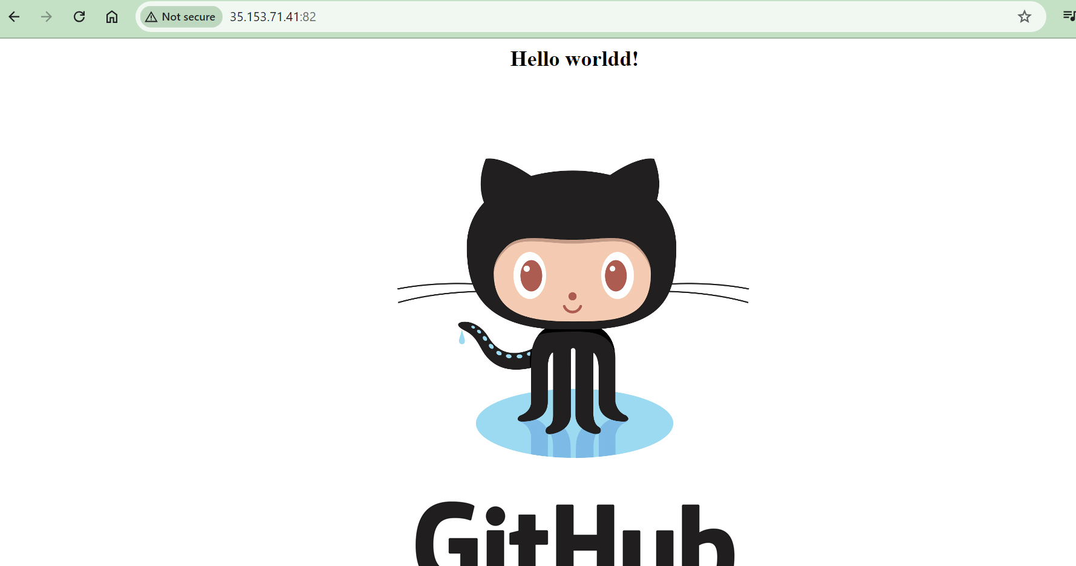

For Prod also we need to run Job3:

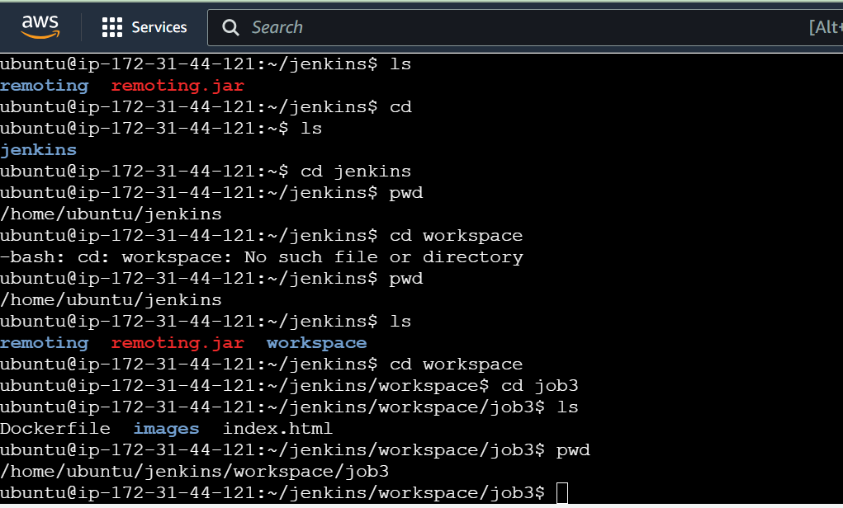

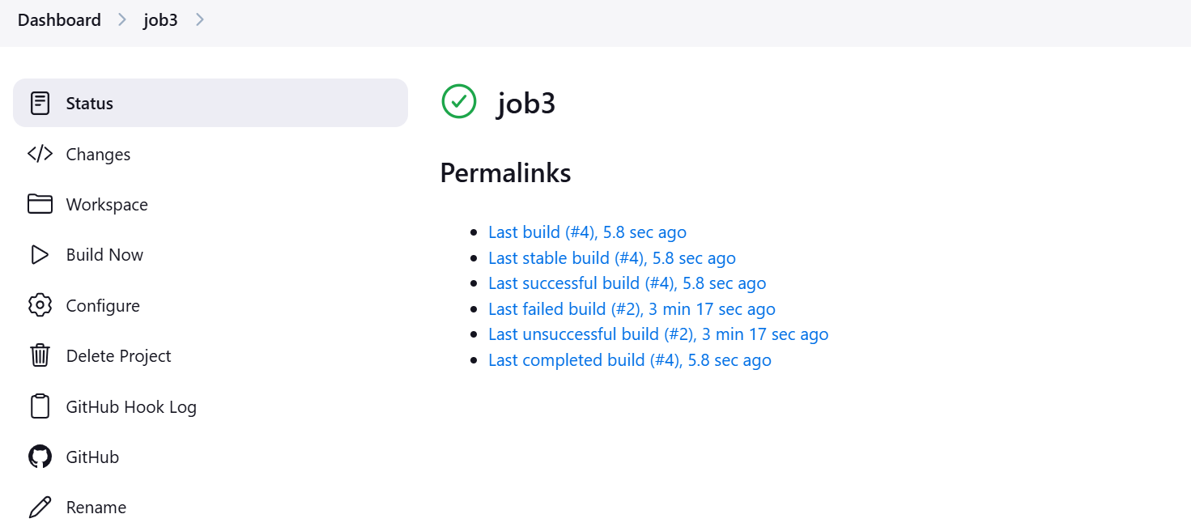

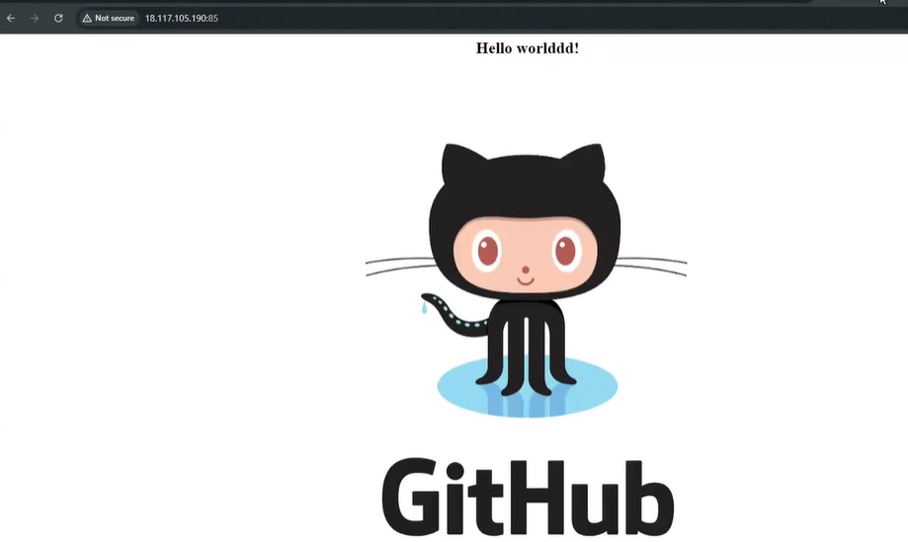

**Master server commands :**

ubuntu@ip-172-31-41-84:/etc/ansible$ history

1 sudo apt-get update

2 sudo apt install software-properties-common

3 sudo add-apt-repository --yes --update ppa:ansible/ansible

4 sudo apt install ansible

5 cd .ssh

6 ssh-keygen

7 ls

8 sudo cat id_rsa.pub

9 cd

10 cd /etc/ansible

11 ls

12 sudo nano hosts

13 ansible -m ping all

14 sudo nano play.yaml

15 sudo nano master.sh

16 sudo nano slave.sh

17 ansible-playbook play.yaml --syntax-check

18 ansible-playbook play.yaml --check

19 ansible-playbook play.yaml

20 sudo apt-get update

21 cd /ctc/ansible

22 cd /etc/ansible

23 sudo cat /var/lib/jenkins/secrets/initialAdminPassword

24 history

**Test Server Commands :**

ubuntu@ip-172-31-36-2:~/jenkins/workspace/job2$ history

1 sudo apt-get update

2 ls

3 cd jenkins

4 pwd

5 cd workspace

6 cd job1

7 ls

8 pwd

9 cd ../

10 ls

11 cd job2

12 ls

13 pwd

14 history

**Prod Server Commands :**

ubuntu@ip-172-31-44-121:~/jenkins/workspace/job3$ history

1 sudo apt-get update

2 cd jenkins

3 ls

4 cd

5 ls

6 cd jenkins

7 pwd

8 cd workspace

9 pwd

10 ls

11 cd workspace

12 cd job3

13 ls

14 pwd

15 history